Binary search

Wednesday, February 22, 2023

8:04 AM

Binary Search

Upper bound and Lower Bound

[c++ - Difference between basic binary search for upper bound and lower bound? - Stack Overflow](https://stackoverflow.com/questions/28389065/difference-between-basic-binary-search-for-upper-bound-and-lower-bound)



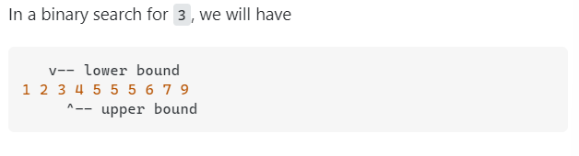

* + In the search for 3, the iterator returned by std::lower_bound would refer to 3 and the one from std::upper_bound would refer to 4

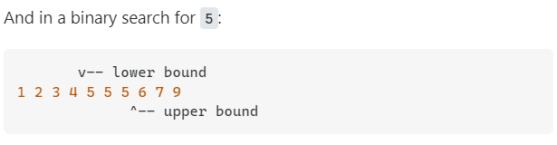

* + In the search for 5, the iterator returned by std::lower_bound would refer to the first 5 and the one from std::upper_bound would refer to 6

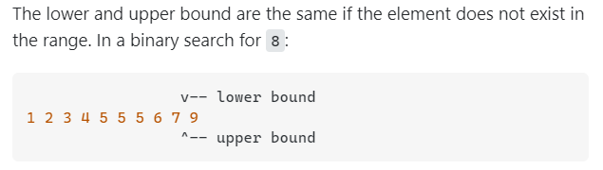

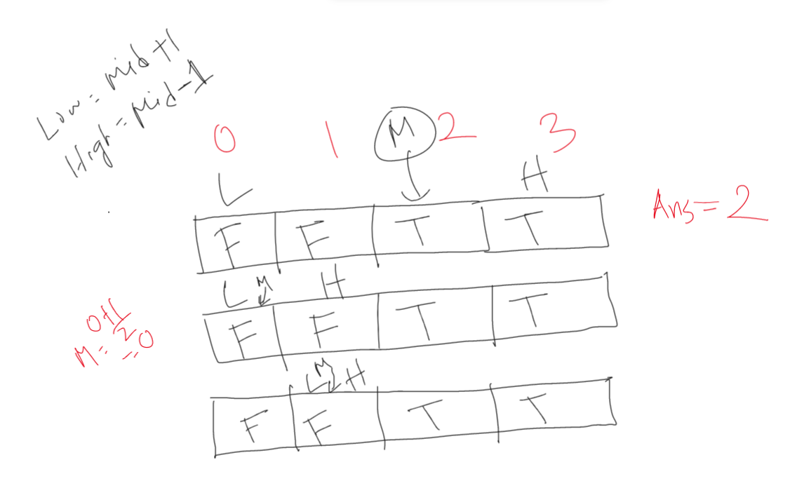

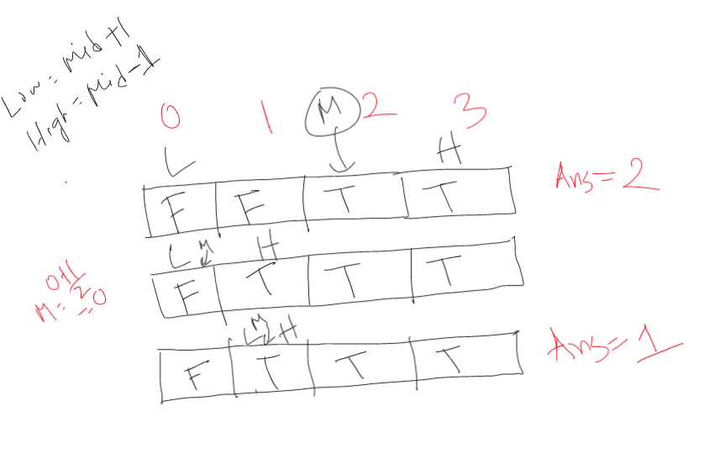

|  |
| --- |
| **int** binary_search**(int** low**,int** high**,**ll arr**[],**ll search**){**  **int** ans**=0;**  **while(**low**<=**high**){**  **int** mid**=(**low**+**high**)/2;**  **if(**arr**[**mid**]>=**search**){**  ans**=**mid**;**  high**=**mid**-1;**  **}else{**  low**=**mid**+1;**  **}**  **}**  **return** ans**;**  **}** |